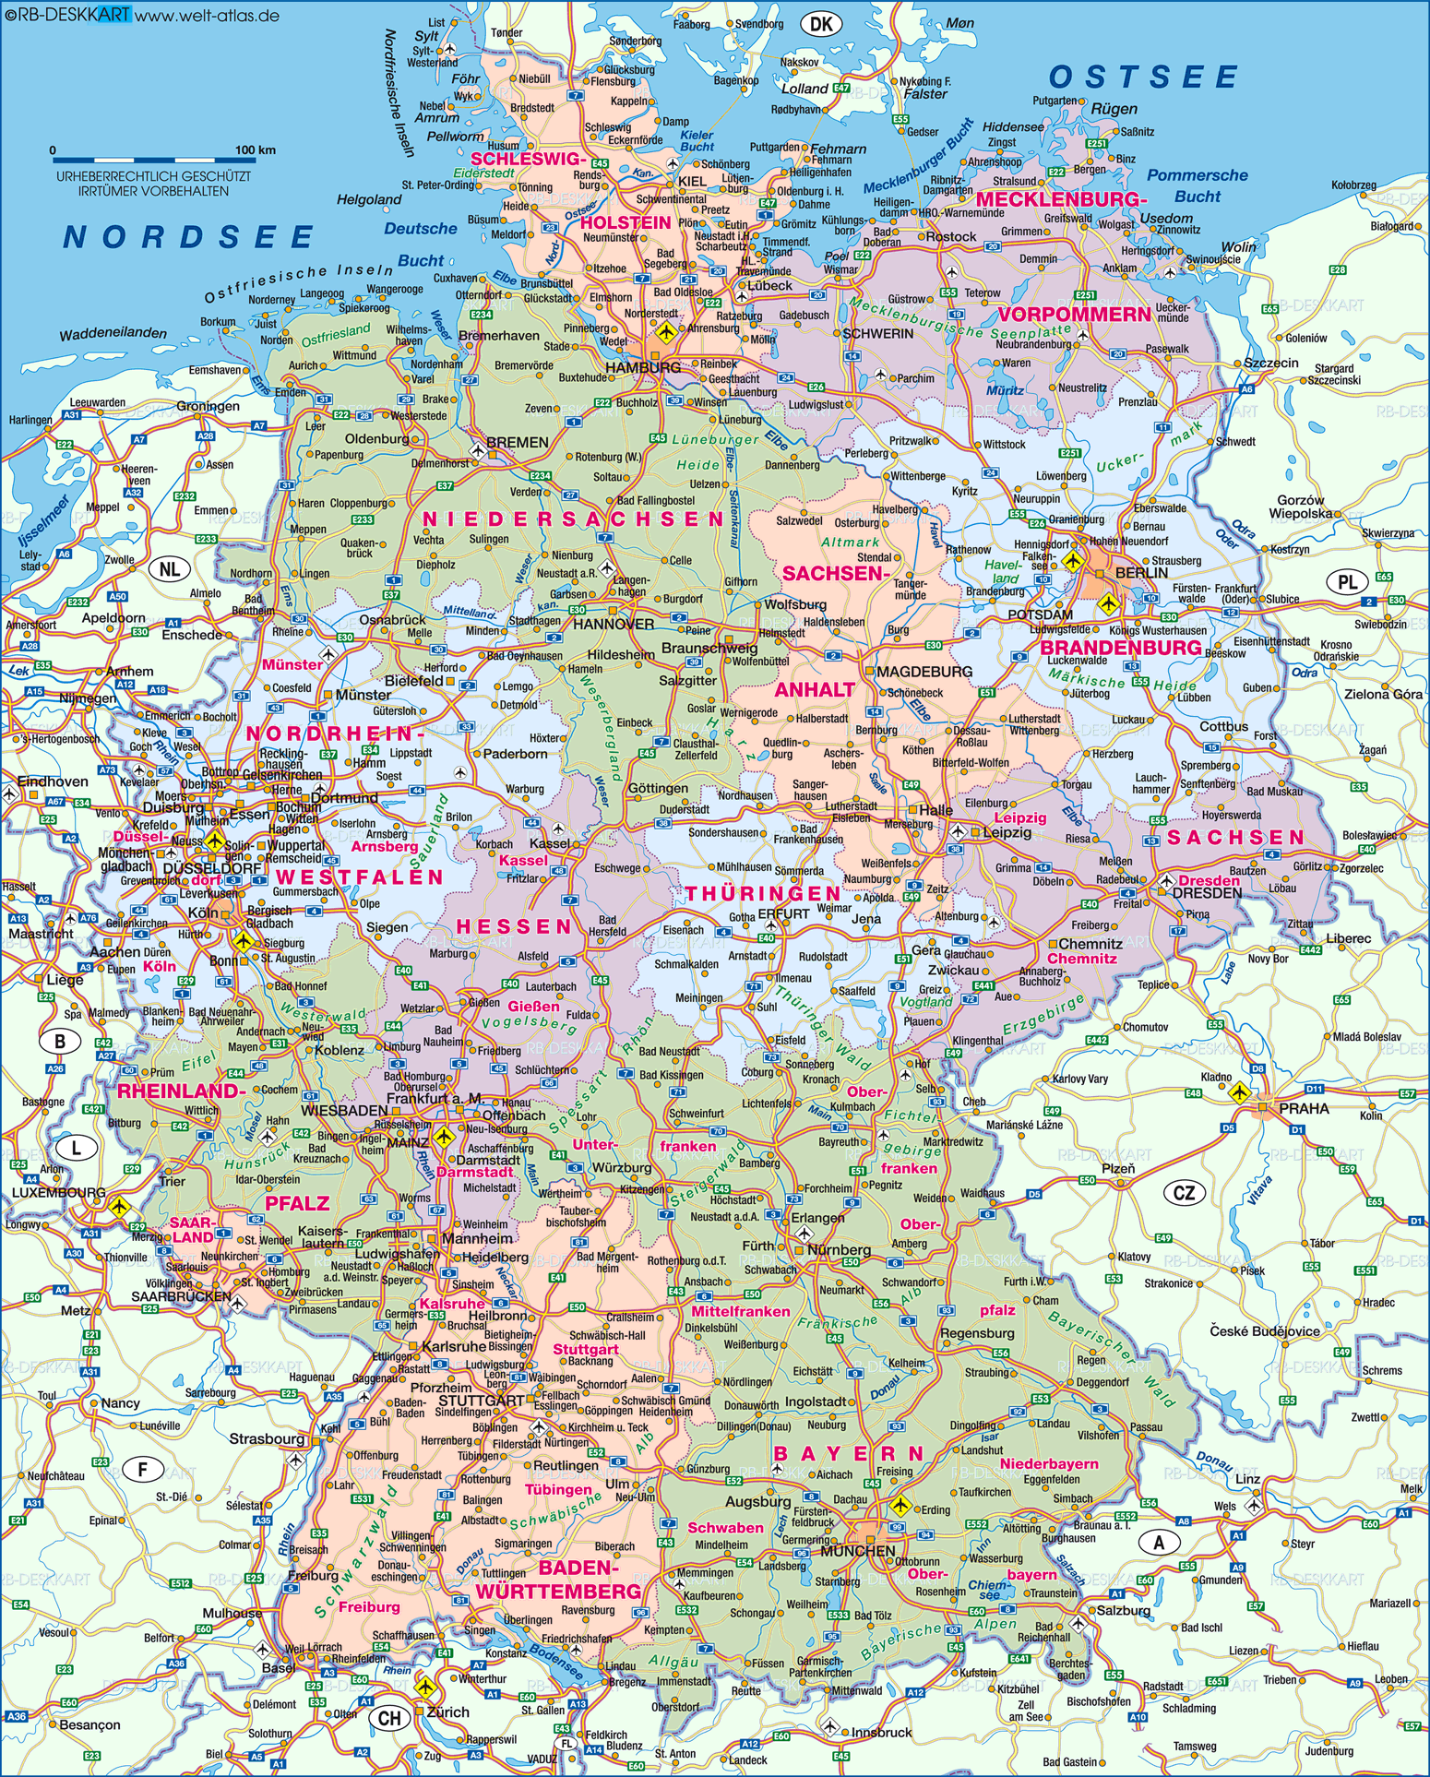

Kiel

**Kiel**

**Rostock**

**Schwerin**

**Hamburg**

**Bremen**

**Berlin**

**Hannover Potsdam**

**Magdeburg**

**Leipzig**

**Düsseldorf**

**Erfurt**

**Dresden**

**Köln**

**Frankfurt**

**Mainz Würzburg**

**Mannheim**

**Nürnberg**

**Saar-**

**brücken**

**Karlsruhe**

**Stuttgart**

**München**

**Freiburg Friedrichshafen**

Description:

General:

By default, main German cities come with the basic map pack. To define the connections, only highways (Autobahnen) and federal highways (Bundesstraßen). Other cities can be added by admin users.

There are two versions oft the same map where the connection weighting factor is distance for one and time for the other.

Connections:

Weighting Factors: distance (km) and time (min). The smallest factor is 1 km and 1 min respectively.